India to grant Nepal access to two key ports in Gujarat & Odisha under trade, transit treaties
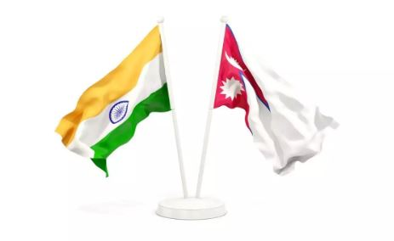
Under its ‘Neighbourhood First’ policy the Narendra Modi government has decided that it will now allow Nepal to export and import goods from two of India’s strategic ports — Mundra Port in Gujarat and Dhamra Port in Odisha — under the yet to be revised transit treaty, negotiations for which are going on.
Such a move, according to sources, will not only give Nepal enhanced entry into the Indian markets but will also enable Kathmandu to use India as a gateway to access other markets in Southeast and Central Asian regions, said a source, who wished to not be identified.
This has been a long-pending demand by Nepal, which had been pushing India for such an up gradation in both the trade as well transit treaties that were signed decades ago.
The agreement was initially finalized as ‘The Treaty of Trade and Transit’ that was signed between the friendly neighbors in September, 1960. Thereafter, in 1978, the treaty was split into two — trade and transit.
The trade treaty allows Nepal unilateral duty-free access to the Indian market even as India remains Nepal’s largest trading partner. However, Nepal continues to complain that it has not been able to penetrate the Indian markets for its good due to various non-tariff barriers.
Source: https://theprint.in/diplomacy/india-to-grant-nepal-access-to-two-key-ports-in-gujarat-odisha-under-trade-transit-treaties/1104496/

